TILDAS Ethane

Quality Assurance Document

Discover AQ Denver 2014

Tara I. Yacovitch and Scott C. Herndon

Aerodyne Research, Inc
45 Manning Road
Billerica, MA 01821
(978) 665-9500

Instrument Details
The TILDAS Ethane instrument details are similar to those described in Yacovitch et al., 2014. Some differences between those instrument details and the instrument used for the Discover AQ Denver project are noted here. The laser is an interband cascade laser (ICL) operated at 3.3 µm (Nanoplus Nanosystems and Technologies S/N = 1418/19-22). This device is swept at 1.8 kHz over a current biasing profile that tunes the laser from 2996.8 – 2997.05 cm⁻¹ and includes a sub lasing threshold to quantify I₀. The spectrum from each sweep is collected and co-added for a number of sweeps that is approximately 1 s in duration. The ethane mixing ratio is quantified using a multicomponent fit of the resulting average spectrum. The spectroscopic constants are taken from Harrison et al. 2010. The multipass absorption cell was maintained at 35 Torr using an MKS flow controller at the base of the inlet. The pumping speed was fixed using a 0.187” disk on the instrument outlet at a “T” manifold installed on the Varian Triscroll 600. This system resulted in a stable flow rate of 8.5 slpm, regardless of the aircraft altitude. At this flow rate, the combined inlet/cell response time was 0.45 s (1/e).
The spectra are all archived at Aerodyne Research Inc. on the ‘caravel’ file server.

Calibration of the Instrument
The pressure and temperature measurements in the absorption cell are a source of systematic error. In order to quantify the effect of unknown systematic error in the measurement as well as quantify the stability of the calibration performance, a surveillance standard was used. Periodically, gas flow from the surveillance tank was used to overblow the inlet. These instrument performance tests were performed in-flight and on the ground in between flights. The results of all calibrations from the surveillance tank overblows are depicted as a histogram in the figure below. The histogram data, fit to a Gaussian function suggests the span stability is 1.7% at 95% confidence interval. Also, the central value is 2.25% less than the INSTARR certified quantification of the surveillance standard. For this reason the final dataset submitted to the ICARTT archive is multiplied by 1.023 (13.33/13.03). Additionally, the overall uncertainty in the quantification is taken to be 2.6%, which is the quadrature summation of the empirical span stability (1.7%) and the overall certainty of the INSTARR quantification (2.0%).
The overall error, attributed above, is likely a conservative estimate. Comparison with a second INSTARR certified tank (performed during the midpoint of the measurement campaign) was only different by better than 1%; 2.98 ppb on the ethane instrument compared to 2.981 ± 0.025 for the INSTARR certification.
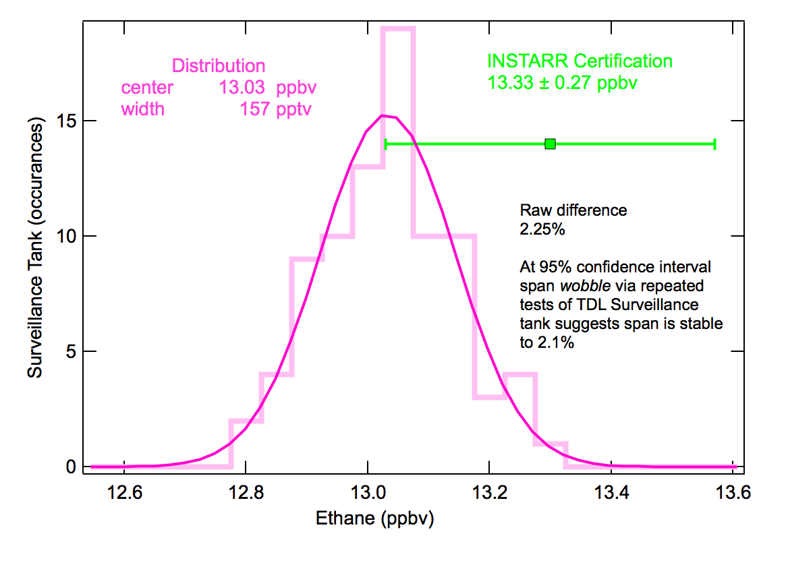
Figure 1. Calibration Summary for Discover AQ – Denver Ethane Measurements. The results of the in-flight surveillance tank overblows are depicted as an unnormalized histogram. The central value of those determinations is 13.0 ppb. The INSTARR certification is denoted visually by the green square labeled “INSTARR Certification”, 13.33 ± 0.27 ppb.

Dataset
All ICARTT data files are available for download here: https://www-air.larc.nasa.gov/cgi-bin/ArcView/discover-aq.co-2014
The data includes the following columns:

Data Column | Definition
StartTime | Measurement time (seconds past midnight).
StopTime | StartTime + 1
MidTime | StartTime + 0.5
C2H6_ppb | Ethane mixing ratio (ppbv)
C2H6_ppb_dry | Ethane dry air mixing ratio (ppbv) calculated using the DLH water measurement (PI: Glenn Diskin)

Time
Time synchronization between the ethane data acquisition computer and the NASA LaRC P3B Data System (PDS, PI: Bruce Anderson) was better than 0.3 seconds for all data. In order to produce data on a unified time basis (with no fractional seconds), the raw data set was interpolated onto the synthetically created StartTime wave. The MidTime and StopTime waves are not meaningful.

Mixing Ratios
The TILDAS Ethane instrument measures the number density of ethane. Using the pressure in the cell and the ideal gas law, this is converted to ppbv. The fact that the ideal gas law is applied uniformly to all species (no matter how ideal) means that mixing ratios are essentially molar mixing ratios, ppb-molar or nano-mol/mol.
The wet mixing ratio of a species s, , is reported.
The dry mixing ratio, , allows for the comparison of different data sets on the same footing.
Combining these two formulas allows for us to calculate a dilution correction to convert wet mixing ratio to dry:

Invalid Data -9999
Calibration and zeroing periods (where an excess of calibration gas or ultrapure zero air was delivered to the inlet) have been excised from the data and replaced with -9999. Any other periods of missing data have been set to -9999.

Noise and Artifacts
High frequency noise in the instrument hovers around 30 ppt (0.03 ppb) when stationary, increasing slightly during turbulent flight. During some periods of the flight, there is a lower-frequency noise signature correlated with the roll of the aircraft. Structure with enhancements above baseline of 0.2 ppb or less may be artifacts of this low-frequency noise signature.

References
Yacovitch, Tara I.; Herndon, Scott C.; Roscioli Joseph R.; Floerchinger, Cody; McGovern, Ryan M.; Agnese, Michael; Pétron, Gabriel; Kofler, Johathan; Sweeney, Colm; Karrion, Anna et al., Demonstration of an ethane spectrometer for methane source identification, Environmental Science and Technology, 2014, 8(14):8028-8034, DOI: 10.1021/es501475q
Harrison, J. J.; Allen, N. D. C.; Bernath, P. F. Infrared absorption cross sections for ethane (C₂H₆) in the 3 μm region. J. Quant. Spectrosc. Radiat. Transfer. 2010, 111, 357; DOI: 10.1016/j.jqsrt.2009.09.010.

