AMLGAS

Aerodyne Mobile Laboratory position, wind, and selected gas-phase tracers.

This data has been averaged onto a 1-minute time base. This is the same time base in use by other AML data including VocusPTRMS, SPAMS and AMS.

Contact data PIs for access to 1-second data.

Table of Contents

firexaq-AMLGAS ICARTT Header 3

Time Series: 3

PI_CONTACT_INFO: 3

PLATFORM: 3

LOCATION: 3

ASSOCIATED_DATA: 4

INSTRUMENT_INFO: 4

UNCERTAINTY: 4

DM_CONTACT_INFO: 4

PROJECT_INFO: 4

STIPULATIONS_ON_USE: 4

OTHER_COMMENTS: 4

Time: UTC, MDT 5

Mobile GPS Coordinates, Wind Measurements, Outdoor Temperatures 5

Data 6

Zeroes, Calibrations, Corrections 8

Data issues 8

Wind Data Issues 8

jNO2_NO_O3P_NCAR_FR 12

Ethyne (C2H2) 13

Calibration, Zeroing, Corrections 13

Data issues 13

HCN 14

Calibration, Zeroing, Corrections 14

Data issues 14

Ethane 14

CH4 17

CO, N2O 21

Data 21

Data issues 21

The post process fix: 22

CO calibrations 23

N2O uncertainty 23

NO, NO2, NH3, SelfSample 25

CO2_ppm 25

O3 27

Data 28

Calibration, Zeroing, Corrections 28

Data issues 29

PAMValve 30

AML_at_AB 30

# firexaq-AMLGAS ICARTT Header

Exerpts from the firexaq-AMLGAS ICARTT header are included below.

Tara Yacovitch, J. Rob Roscioli, Conner Daube, Christoph Dyroff, Scott Herndon

Aerodyne Research, Inc.

Aerodyne Mobile Lab

FIREX AQ 2019

2019, 08, 07, 2020, 05, 12

## Time Series:

Time_Start, seconds_past_midnight, UTC

Time_Stop, seconds_past_midnight, UTC

Time_Mid, seconds_past_midnight, UTC

MM_MDT, seconds_past_midnight, Time_MountainDaylightTime

MM_Latitude, deg, Platform_Latitude_InSitu_None

MM_Longitude, deg, Platform_Longitude_InSitu_None

MM_Easting, m, Platform_Easting_InSitu_UniversalTransverseMercator

MM_Northing, m, Platform_Northing_InSitu_UniversalTransverseMercator

MM_Zone, unitless, Platform_Zone_InSitu_UniversalTransverseMercator

MM_truckHeading, deg, Platform_HeadingTrue_InSitu_None

MM_truckSpeed_kmph, kmph, Platform_GroundSpeed_InSitu_None

MM_Elevation_m, m, Platform_AltitudeMSL_InSitu_None

MM_wind_speed_metersPerSecond, m/s, Met_WindSpeed_InSitu_None

MM_wind_dir_degrees, deg, Met_WindDirection_InSitu_None

MM_wind_N_metersPerSecond, m/s, Met_VWindSpeed_InSitu_None

MM_wind_E_metersPerSecond, m/s, Met_UWindSpeed_InSitu_None

MM_truckTemperature_C, deg, Met_StaticAirTemperature_InSitu_None

MM_SEA, deg, Met_SolarAzimuthAngle_InSitu_None

MM_jNO2_NO_O3P_NCAR_FR, /s, GasJvalue_jNO2_modeled_total_NO-O3P

MM_AML_at_AB, unitless, Platform_atActivityBarnFLAG_InSitu_Yes1No0

MM_PAMValve, unitless, Platform_inletFLAG_InSitu_PAM-1-ambient-0

MM_SelfSample, unitless, Platform_exhaustFLAG_InSitu_Ambient-1-SelfSample-9999

## PI_CONTACT_INFO:

herndon@aerodyne.com; tyacovitch@aerodyne.com; roscioli@aerodyne.com; daube@aerodyne.com;

## PLATFORM:

Aerodyne Mobile Laboratory

## LOCATION:

Based out of McCall, ID; fires visited: Nethker (ID), Castle/Ikes (AZ), Cow (OR), McCall Prescribed Burn (ID)

## ASSOCIATED_DATA:

VocusPTRMS (PI: Majluf);

AMS and SPAMS (PI: Fortner);

SP2BNL (PI: Onasch);

jNO2 (PIs: Ullman and Hall);

All McCall Ground Site data

## INSTRUMENT_INFO:

TILDAS instruments for CH4, C2H6, CO, N2O, H2O, HCHO, HCOOH, HCN, C2H2, NO, NO2, NH3; Licor 6262 for CO2; 2B-Tech for O3; RMYoung 86000 for wind;

Hemisphere GPS Vector V103;

Metcon filter radiometer for jNO2 (UCAR); see QA file

DATA_INFO: Duty Cycle: 93%; Measurement frequency/period: most species (except for O3) measured at 1Hz (period of 1 sec) and interpolated onto the same 1 min time base

## UNCERTAINTY:

Uncertainty varies for each instrument

ULOD_FLAG: -7777

ULOD_VALUE: N/A

LLOD_FLAG: -8888

LLOD_VALUE: N/A

## DM_CONTACT_INFO:

Tara Yacovitch, tyacovitch@aerodyne.com

## PROJECT_INFO:

FIREX 2019 based out of McCall ID: <https://www.esrl.noaa.gov/csl/projects/firex-aq/mobilelabAerodyne/>

## STIPULATIONS_ON_USE:

Use of these data require prior ok from PI.

## OTHER_COMMENTS:

This file contains 1-min data averages. Contact PIs for 1-sec data. See QA document for additional details. Three Flag datasets are included to identify periods where the AML was at the Activity Barn Ground Site in McCall ID; when the AML inlet sampled through the PAM; and when the AML data was not affected by self-sampling of its own exhaust

# Time: UTC, MDT

All data is reported in universal coordinated time (UTC). For convenience, local time during the campaign (MDT) is also reported.

This time base is a synthetic 1-minute time base. Since it was set prior to the campaign, it includes times before instrumentation was operational. Data during these periods are set to NaN (or -9999).

# Mobile GPS Coordinates, Wind Measurements, Outdoor Temperatures

Tara Yacovitch, [tyacovitch@aerodyne.com](mailto:tyacovitch@aerodyne.com)

The Hemisphere GPS compass, model Vector V103, was mounted to the AML rooftop. Another unit was mounted to the minAML rooftop.

Mobile wind was collected with a 2D RMYoung ultrasonic anemometer, model 86000, mounted to the AML rooftop above the driver at a height of 3.75 meters. Vehicle speed and heading from the GPS compass was used to correct the raw apparent wind into true wind.

A second 3D RMYoung ultrasonic anemometer, model 81000RE, was also mounted to the AML boom, and is used for outdoor temperature. Wind data from this unit is not reported because winds from the rear are shielded by the vehicle body.

The algorithm used to subtract AML motion from apparent wind was exhaustively tested. Two versions of the algorithm were used. The first, appropriate for sea vessels or aircraft, subtracted course-over-ground and heading in two steps. This algorithm is shown for the 2D anemometer in the graph below:

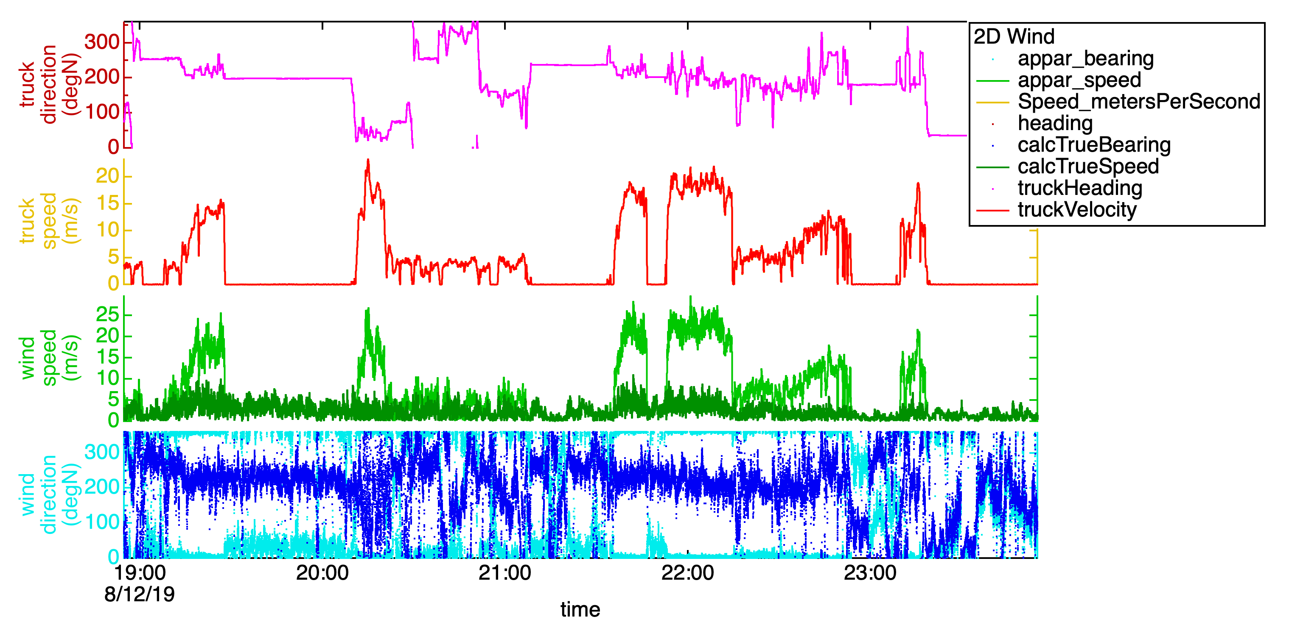

The second method, appropriate only for land vehicles with heading identical to course-over-ground, performed a simpler vector subtraction using heading. Both methods are shown for the 3D anemometer in the graph below.

For this dataset, the 3D correction occasionally yields inconsistent results for wind direction. For example, in the graph below, around 19:20, wind direction seems to change with truck speed. The rest of the time, the algorithms are comparable. The simple algorithm is used throughout.

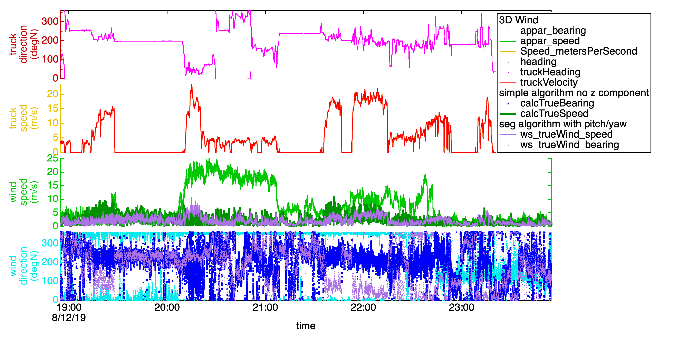

### Data

|  |  |  |  |
| --- | --- | --- | --- |
| Name | Unit | Location | Note |
| MM_SEA | azimuthal degrees | ground site | Calculated solar elevation angle at the AML coordinates |
| MM_Latitude | decimal degrees | AML | Mobile and stationary location of the AML |
| MM_Longitude | decimal degrees | AML |  |
| MM_Northing | UTM meters north | AML |  |
| MM_Easting | UTM meters east | AML |  |
| MM_Zone | UTM zone | AML |  |
| MM_Elevation_m | meters | AML | Elevation of the AML relative to sea level, mobile and stationary. Measured by on-board GPS. |
| MM_truckHeading | degrees clockwise from true north | AML | Direction of the AML relative to true north. A heading of 45 degrees indicates that the AML is pointed north-east. Uses the HEHDT sentence type from the GPS compass. Calculated using the mobile lab speed vector interpolated onto the 1-min time base. |
| MM_truckSpeed_kmph | kilometers per hour | AML | Uses the GPVTG sentence type from GPS compass. Calculated using the mobile lab speed vector interpolated onto the 1-min time base. |
| MM_truckTemperature_C | degrees Celsius | AML | Sonic temperature measured by the RMYoung 3D anemometer on the AML mast. |
| MM_wind_dir_ degrees | degrees clockwise from true north | AML | Mobile or stationary incident wind direction aboard the AML, at 3.75 meters. A wind of 90 degrees indicates wind from the East. |
| MM_wind_speed_ metersPerSecond | m/s | AML | Mobile or stationary incident wind speed aboard AML, at 3.75 meters. |
| MM_wind_N_ metersPerSecond | m/s | AML | Vector representation of AML wind, with positive axis corresponding to wind with a component from the north. |
| MM_wind_E_ metersPerSecond | m/s | AML | Vector representation of AML wind, with positive axis corresponding to wind with a component from the east. |

### Zeroes, Calibrations, Corrections

**Interpolation of polar values:** Since a heading of 360 degrees is the same as a heading of 0 degrees, interpolation cannot be done directly without causing artifacts (e.g. averaged headings of ~180 when true heading is 0/360). Instead, a unit vector pointing in the direction of heading was calculated in x and y coordinates. Those x and y coordinates were averaged onto the 1-minute time base, and the result re-converted into a heading in degrees. Similarly, all wind measurements were interpolated onto a 1-minute time base using their vector components, and only then transformed back into speed and direction.

**Winds:** No calibration of the various anemometers was performed. A comparison between the 2D and 3D anemometers mounted on the AML, and the truck speed shows that there is a bias in the apparent wind. This is described in the next section.

### Data issues

Sonic temperatures may have a slight humidity dependence. However, previous campaigns have shown good comparisons with other temperature measurements with no obvious humidity effects.

The GPS compass has an internal gyroscope which is used to measure pitch, roll, yaw and course over ground. Ground vehicles should have course over ground identical to their heading. Previous campaigns showed that a comparison of the two showed deviations in course over ground correlating to glitches in pitch, which may be due to malfunctioning of the gyroscope on bumpy roads. For this reason, the course-over-ground was not used in calculation of mobile wind, using instead the more reliable heading. Previous campaigns also showed that the nature of the bumps encountered in the AML may be causing problems with the gyroscope. No data is reported for pitch, roll or yaw.

Safe driving and legal height restrictions on the AML restrict how high the 2D anemometer can be lofted above the vehicle roof plane. The height of the wind sensor was a maximum of 6 inches above the rooftop. As a result, mobile wind measurements, particularly at high speeds, may be influenced by the aerodynamics of the vehicle. Winds during the campaign were often light and variable, making diagnosing issues with mobile wind difficult. Currently, use caution when interpreting mobile wind, particularly at low wind speeds and/or high truck speeds.

### Wind Data Issues

* 2D anemometer (this is the data that was pushed forward into MM_wind)
* 3D anemometer (this is NOT the MM wave)

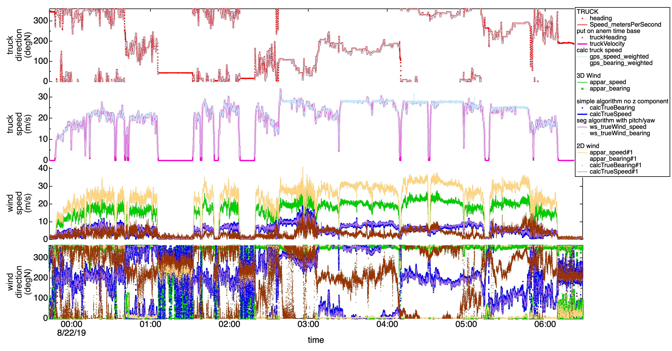

Two apparent winds are present:

1. 3D RMYoung (green)
2. 2D RMYoung (yellow)

The first thing that is clear is the very different wind magnitudes in the apparent wind. The magnitude of the difference seems consistent regardless of truck direction, but collapses when stationary. Apparent direction is consistent between the two anemometers except for when apparent wind is from the truck rear. In this case (e.g. 8/22/19 2:15 UTC) the 3D anemometer shows a large amount of spread in direction while the 2D anemometer does not.

Which wind speed is correct? We can look at times when the truck speed is fast and compare.

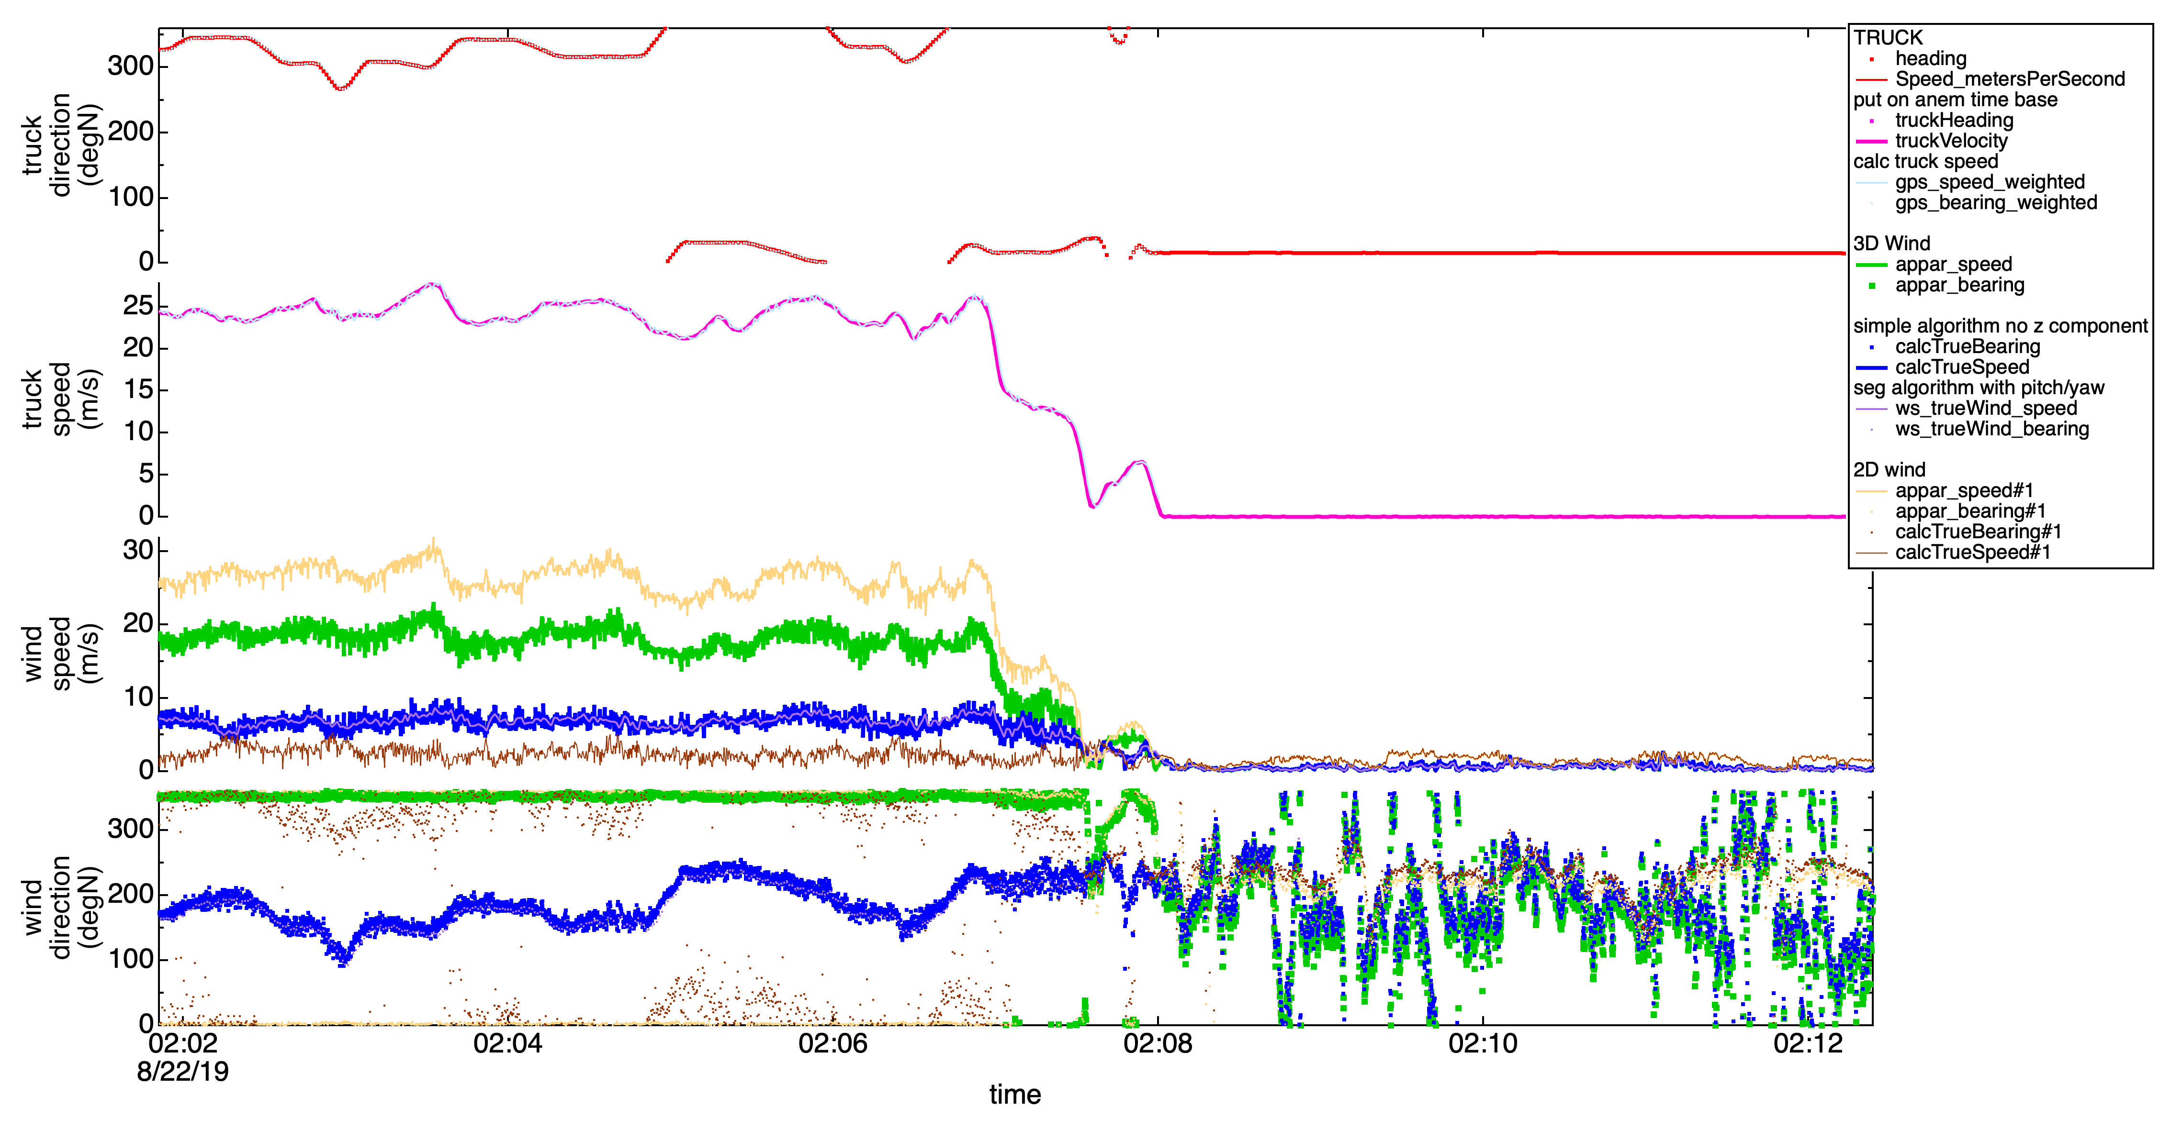

Above you can see the truck is going ~25 m/s. Wind speeds when stopped are low, ~0.5 m/s.

The peak speed in this graph is 25.9 m/s. At this time, the 2D anemometer reads 28.4 (too high by 9%) and the 3D reads 19 m/s (too low by 27%).

This is also shown when plotting all of the data. Apparent wind speed is plotted against truck velocity. The intercept held at 0 m/s to help guard against outsize influence of real wind at low truck speeds, and a linear fit performed. In the graph below, the 2D apparent speed is high by 13%, and the 3D is low by 22%.

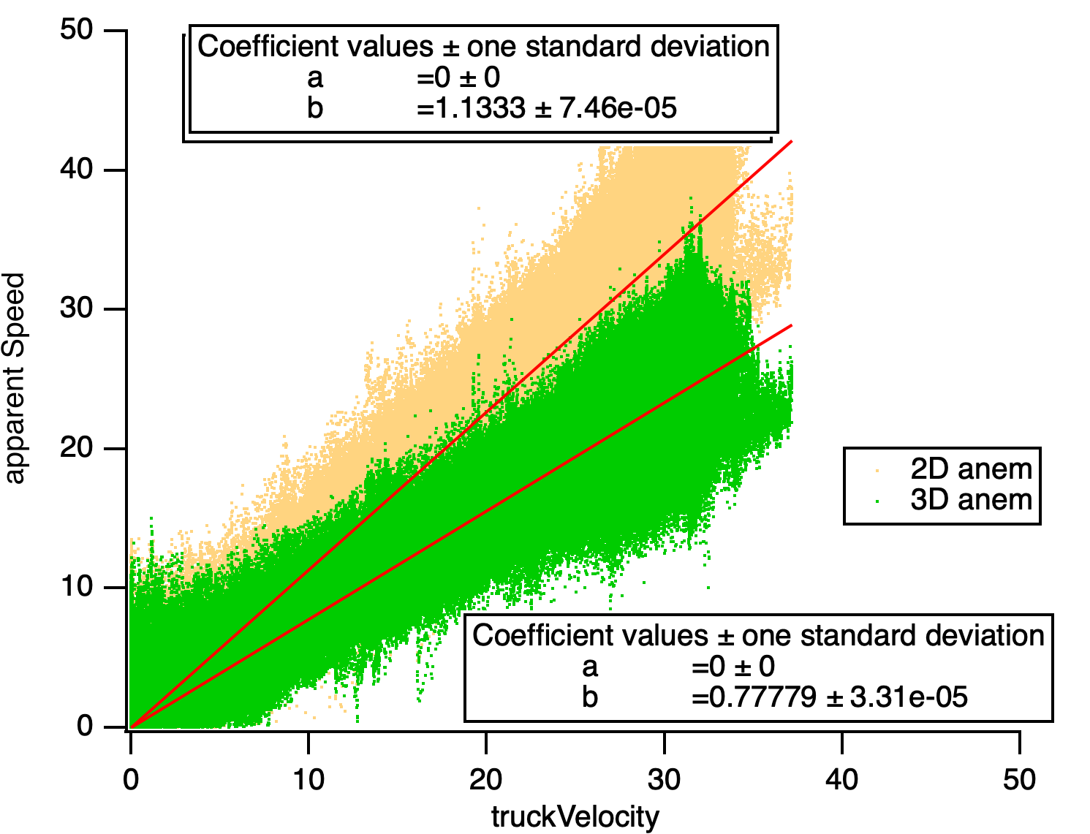

We can look at the bias in uu and vv directions:

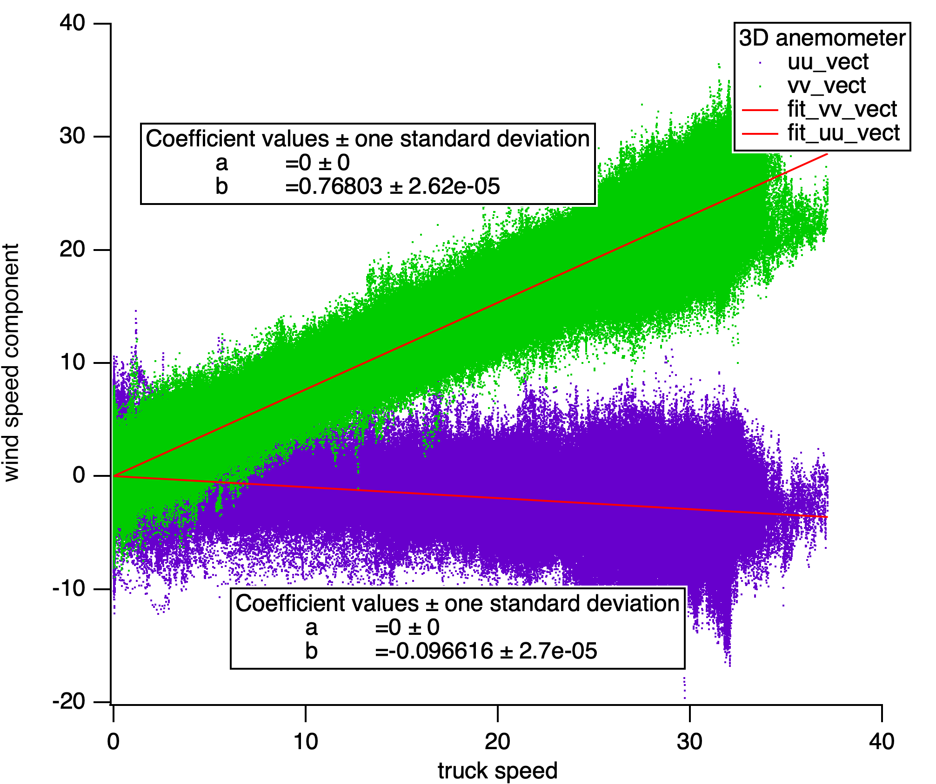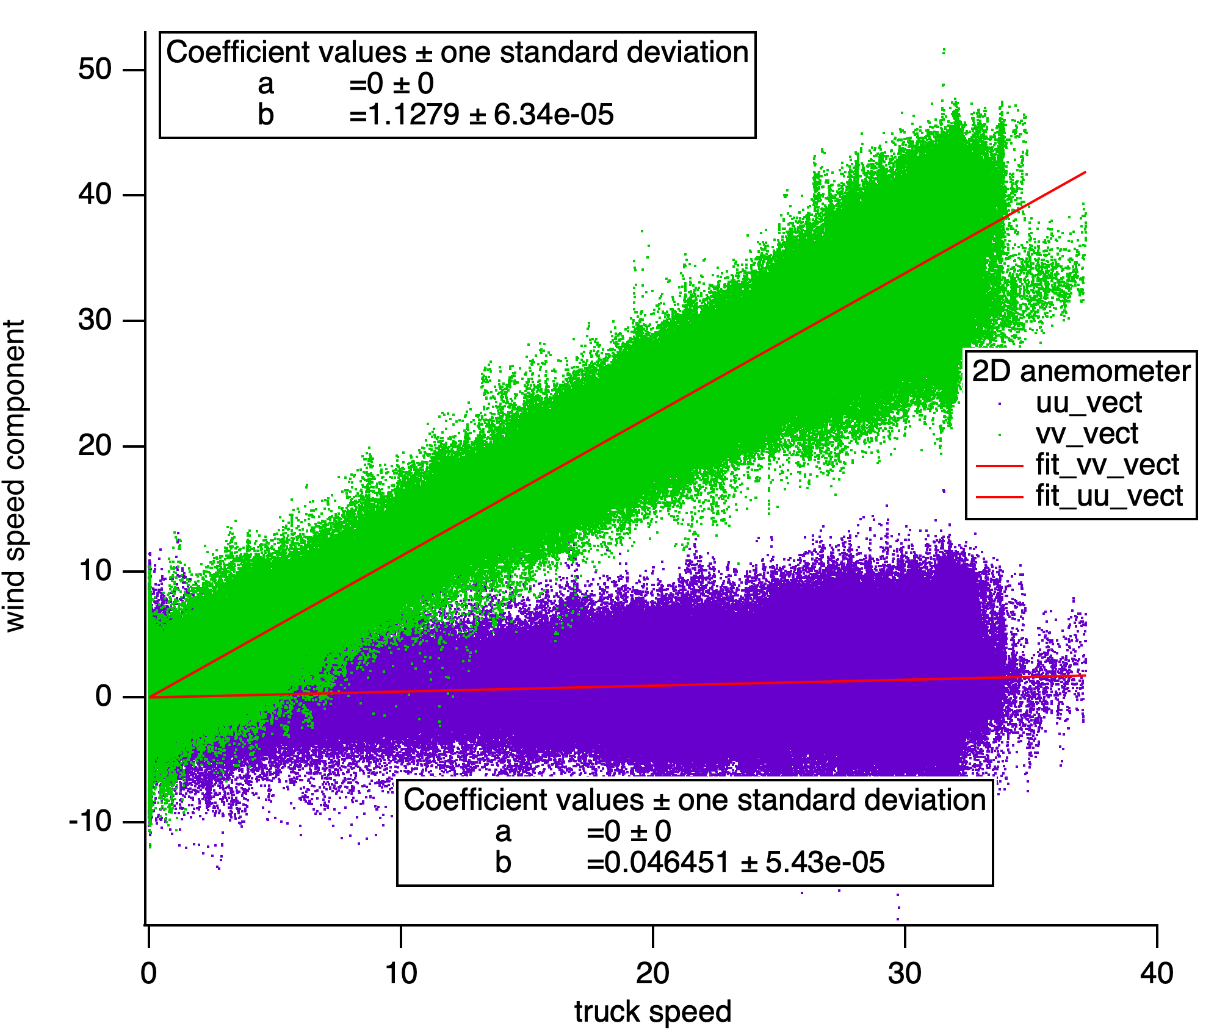

Calculating true wind has been done in three ways:

1. Subtraction of truck speed from 3D RMYoung, including pitch, yaw, roll (light purple)
2. Standard subtraction of truck speed from 3D RMYoung, not including vertical wind (blue)
3. Standard subtraction of truck speed from 2D RMYoung, not including vertical wind (brown)

Truck speed is from the GPS compass (red and pink). It has been verified by recalculating speed based on GPS position (pale blue). If we trust our GPS position, then the truck speed is trusted.

Wind methods 1 and 2 yield consistent results. (blue/purple). So the method is not at question, and this is not a problem due to excessive pitch/roll/yaw.

All 3D anemometer data is quite affected by truck speeds (compare blue true wind speed to pink true truck speed). 2D is also affected, but to a lesser extent.

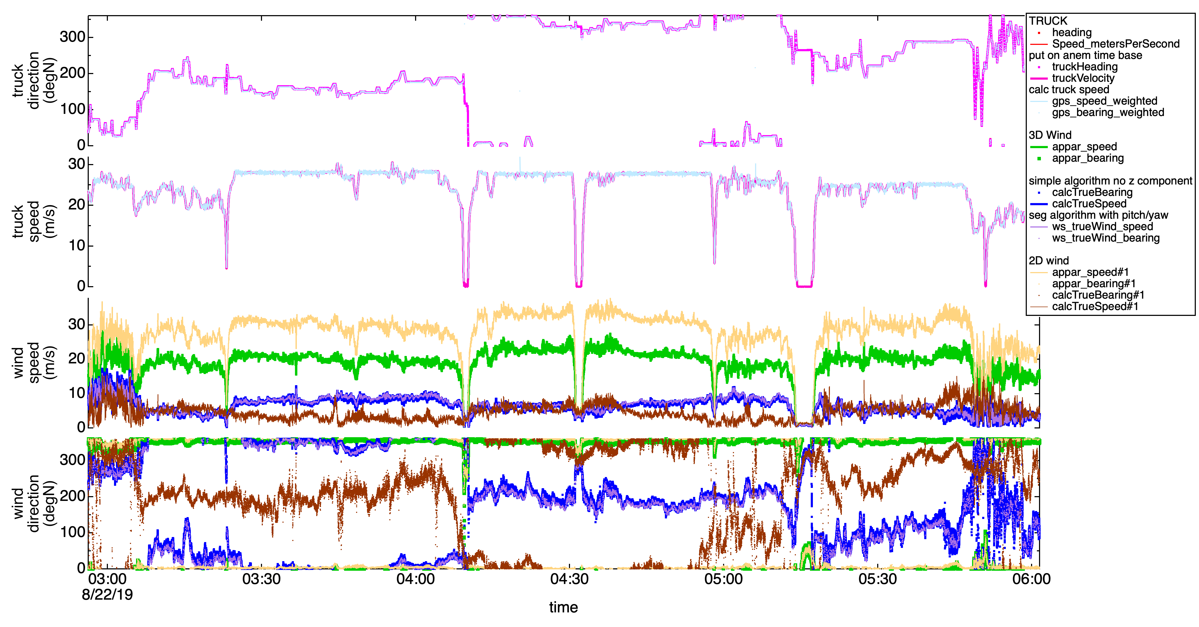

The MM_wind data on owncloud is the 2D data (brown), which is the most accurate wind (but still biased).

Wind direction is particularly bad in the time period above because wind speeds are less than 3 m/s (based on data when stationary at 4:10) and truck speeds are high (almost 30 m/s). True wind direction at 8/22/2019 4:10 while stationary is between 19 and 32 degrees (from the NNE).

We will attempt to scale the apparent wind speeds and recalculate true wind in future data revisions.

# jNO2_NO_O3P_NCAR_FR

Downwelling component of the NO2 photolysis frequency, s-1.

Kirk Ullman [ullmannk@ucar.edu](mailto:ullmannk@ucar.edu) and Samuel Hall [halls@ucar.edu](mailto:halls@ucar.edu)

The downwelling component of the NO2 photolysis frequency (jNO2) was measured continuously from a filter radiometer (Metcon, GmbH) on the AML roof. The reported total jNO2 is calculated from up/down ratios produced using the Tropospheric Ultraviolet and Visible (TUV) radiative transfer model run with a surface albedo of 0.10, the GPS coordinates of the AML, and a measurement altitude of 3m above ground level. Data will have greatly increasing errors when the solar zenith angle is in the range of 80-90 degrees.  For more detail and 1 Hz downwelling data, refer to the NASA FIREX-AQ data archive at <https://www-air.larc.nasa.gov/missions/firex-aq/index.html>.

# Ethyne (C2H2)

Ethyne, aka acetylene (C2H2) in ppb. Ambient humidity. TILDAS HCN/C2H2 instrument

Christoph Dyroff, Aerodyne Research, Inc., [cdyroff@aerodyne.com](mailto:cdyroff@aerodyne.com).

This instrument measures HCN and C2H2 (discussed here) at 3 microns using tunable infrared laser direct absorption spectrometry (TILDAS). The instrument was mounted on AML during FIREX 2019. The 1-sec noise of this instrument is around 40 ppt for C2H2.

Notably, the C2H2 exhibited some drift due to variations in the laser tuning rate. This variation was likely caused by changes in instrument temperature. Frequently this lead to jumps every 15 minutes (on the auto-zeroing schedule) that can sometimes be in excess of 100 ppt.

### Calibration, Zeroing, Corrections

The instrument was calibrated on 08/14/2019, and the calibration factor for C2H2 was 0.8325. The reported data is therefore corrected by 1/0.8325. The instrument was zeroed every 15 minutes by overblowing the communal inlet with ultra zero air.

Figure : Calibration of C2H2 on 08/14/2019.

### Data issues

In addition to the calibration correction, data was filtered for the following:

* filtered out data with apparent jumps/shifts in peak position
* filtered out calibration intervals
* filtered out obviously wrong C2H2 values (negative or extremely high)

On 06/25/2019, a major error in instrument time was corrected. This affected data between 8/13/19 10:43:20 - 8/15/19 20:59:59, which was 4 hours offset. R1 data is corrected.

# HCN

Hydrogen cyanide (HCN) concentration in ppb. Ambient humidity. TILDAS HCN/C2H2 instrument

Christoph Dyroff, Aerodyne Research, Inc., [cdyroff@aerodyne.com](mailto:cdyroff@aerodyne.com).

This instrument measures HCN and C2H2 (discussed here) at 3 microns using tunable infrared laser direct absorption spectrometry (TILDAS). The instrument was mounted on AML during FIREX 2019. The 1-sec noise of this instrument is around 60 ppt for HCN.

Notably, the HCN exhibited some drift due to variations in the laser tuning rate. This variation was likely caused by changes in instrument temperature. Frequently this lead to jumps every 15 minutes (on the auto-zeroing schedule).

### Calibration, Zeroing, Corrections

The instrument was calibrated on 08/14/2019 and 08/24/2019, and the average calibration factor for HCN was 1.0128. The reported data is therefore corrected by 1/1.0128. The instrument was zeroed every 15 minutes by overblowing the communal inlet with ultra zero air.

Figure : Calibration of HCN on 08/14/2019 and 08/24/2019.

### Data issues

In addition to the calibration correction, data was filtered for the following:

* filtered out data with apparent jumps/shifts in peak position
* filtered out calibration intervals
* filtered out obviously wrong HCN values (negative or extremely high)

On 06/25/2019, a major error in instrument time was corrected. This affected data between 8/13/19 10:43:20 - 8/15/19 20:59:59, which was 4 hours offset. R1 data is corrected.

# Ethane

Ethane (C2H6) concentration in ppb. Ambient humidity. TILDAS C2H6/CH4 instrument

Conner Daube, Aerodyne Research, Inc., [daube@aerodyne.com](mailto:daube@aerodyne.com)

For the FIREX-AQ field campaign, this instrument employing tunable infrared laser direct absorption spectroscopy around 3 microns was used to measure the concentration of ethane in parts-per-billion (ppb).

Data was corrected for time periods during zero overblows (every 15 min) and adjusted to account for variability (1 second start slop, 3 second end slop). Gaps in data greater than 3 seconds were removed. Time periods identified during the campaign classified as “Blacklist”, “Self-Sampling”, and “Calibration” were removed.

An in-field calibration on 8/14/2019 using Ethane 3 diluted with zero air resulted in a calibration factor of 0.8499. Subsequently, C2H6 data was divided by this calibration factor across the entirety of the campaign.



**Calibration tank**: “Ethane 3” (1 ppm C2H6)

**Igor command** (includes correction for Alicat MFC flow using secondary flow meters):

ethane3_C2H6_cal:=1000*(ethane3_flow*1.1902)/(ethane3_flow/1.1902 + ethane3_UZA_flow*1.227)

**Additional NaN periods and Igor commands**

Manual blacklist times (in addition to in-field designations):

|  |  |  |
| --- | --- | --- |
| Start time | End time | Class name |
| 8/8/2019 0:18:42 | 8/8/2019 0:18:45 | Blacklist |
| 8/8/2019 0:19:58 | 8/8/2019 0:20:00 | Blacklist |
| 8/8/2019 15:44:41 | 8/8/2019 15:44:51 | Blacklist |
| 8/8/2019 16:03:33 | 8/8/2019 16:09:54 | Blacklist |
| 8/8/2019 16:23:12 | 8/8/2019 16:32:39 | Blacklist |
| 8/8/2019 20:30:01 | 8/8/2019 20:37:01 | Blacklist |
| 8/8/2019 21:03:23 | 8/8/2019 21:04:51 | Blacklist |
| 8/8/2019 21:12:31 | 8/8/2019 21:14:47 | Blacklist |
| 8/8/2019 21:19:40 | 8/8/2019 21:21:57 | Blacklist |
| 8/8/2019 21:37:06 | 8/8/2019 21:39:13 | Blacklist |
| 8/9/2019 14:35:31 | 8/9/2019 14:36:00 | Blacklist |
| 8/9/2019 14:39:18 | 8/9/2019 14:39:25 | Blacklist |
| 8/9/2019 16:53:56 | 8/9/2019 17:00:09 | Blacklist |
| 8/9/2019 17:45:26 | 8/9/2019 17:45:48 | Blacklist |
| 8/9/2019 22:30:18 | 8/9/2019 22:36:23 | Blacklist |
| 8/9/2019 23:08:54 | 8/9/2019 23:11:12 | Blacklist |
| 8/11/2019 21:00:29 | 8/11/2019 21:00:55 | Blacklist |
| 8/12/2019 15:43:22 | 8/12/2019 15:49:33 | Blacklist |
| 8/13/2019 14:48:11 | 8/13/2019 14:54:04 | Blacklist |
| 8/13/2019 20:29:37 | 8/13/2019 21:00:56 | Blacklist |
| 8/14/2019 2:23:02 | 8/14/2019 2:27:00 | Blacklist |
| 8/14/2019 17:34:08 | 8/14/2019 17:35:06 | Blacklist |
| 8/14/2019 18:29:43 | 8/14/2019 18:30:18 | Blacklist |
| 8/14/2019 19:50:39 | 8/14/2019 20:05:49 | Blacklist |
| 8/14/2019 20:09:57 | 8/14/2019 20:43:31 | Blacklist |
| 8/14/2019 20:00:46 | 8/15/2019 0:34:47 | Blacklist |
| 8/15/2019 0:25:31 | 8/15/2019 1:49:03 | Blacklist |
| 8/15/2019 22:30:21 | 8/15/2019 22:30:55 | Blacklist |
| 8/16/2019 16:49:24 | 8/16/2019 16:49:33 | Blacklist |
| 8/16/2019 18:57:08 | 8/16/2019 19:30:19 | Blacklist |
| 8/17/2019 18:24:29 | 8/17/2019 18:46:45 | Blacklist |
| 8/18/2019 18:35:47 | 8/18/2019 19:22:34 | Blacklist |
| 8/18/2019 19:32:49 | 8/18/2019 19:34:18 | Blacklist |
| 8/18/2019 20:12:20 | 8/18/2019 20:14:12 | Blacklist |
| 8/23/2019 22:16:32 | 8/23/2019 22:18:21 | Blacklist |
| 8/23/2019 22:31:32 | 8/23/2019 22:32:54 | Blacklist |
| 8/23/2019 22:43:23 | 8/23/2019 22:44:39 | Blacklist |
| 8/23/2019 22:47:59 | 8/23/2019 22:49:31 | Blacklist |
| 8/23/2019 22:55:13 | 8/23/2019 22:57:56 | Blacklist |
| 8/24/2019 18:26:58 | 8/24/2019 18:51:33 | Blacklist |
| 8/24/2019 20:45:47 | 8/24/2019 20:58:47 | Blacklist |
| 8/26/2019 4:42:18 | 8/26/2019 4:54:37 | Blacklist |
| 8/26/2019 5:51:16 | 8/26/2019 5:55:09 | Blacklist |
| 8/28/2019 14:22:50 | 8/28/2019 15:06:27 | Blacklist |
| 8/28/2019 15:05:13 | 8/28/2019 15:36:11 | Blacklist |

General QA commands

QAQCw_ResetAllWaves()

QAQCw_NanThisClass("Blacklist;SelfSampling;Calibration")

QAQCw_NaNlargeDataGaps("C2H6",3)

QAQCw_NaNZeroes(1,3)

Casting to MM wave

Cast_AnyXYontoPilot( pilot, root:FIREX19:str_source_rtime, root:FIREX19:C2H6_NaNed, "MM_C2H6", "script_set" );

Manual NaNs

QAQCw_NaNperiod("C2H6",3648124799.0,3648126758.0,0,0) //08/08/2019 15:59:59, 08/08/2019 16:32:38

QAQCw_NaNperiod("C2H6",3648145707.0,3648145722.0,0,0) //08/08/2019 21:48:27, 08/08/2019 21:48:42;

QAQCw_NaNperiod("C2H6",3648145737.0,3648145752.0,0,0) //08/08/2019 21:48:57, 08/08/2019 21:49:12;

QAQCw_NaNperiod("C2H6",3648145776.0,3648145791.0,0,0) //08/08/2019 21:49:36, 08/08/2019 21:49:51;

QAQCw_NaNperiod("C2H6",3648818973.0,3648819039.0,0,0) //08/16/2019 16:49:33, 08/16/2019 16:50:39;

# CH4

Methane (CH4) concentration in ppb. Ambient humidity. TILDAS C2H6/CH4 instrument

Conner Daube, Aerodyne Research, Inc., [daube@aerodyne.com](mailto:daube@aerodyne.com)

For the FIREX-AQ field campaign, this instrument employing tunable infrared laser direct absorption spectroscopy around 3 microns was used to measure the concentration of methane in parts-per-billion (ppb).

Data was corrected for time periods during zero overblows (every 15 min) and adjusted to account for variability (1 second start slop, 3 second end slop). Gaps in data greater than 3 seconds were removed. Time periods identified during the campaign classified as “Blacklist”, “Self-Sampling”, and “Calibration” were removed.

An in-field calibration on 8/14/2019 using FIREX CH4 diluted with zero air resulted in a calibration factor of 0.9435. Subsequently, CH4 data was divided by this calibration factor across the entirety of the campaign.



**Calibration tank**: “FIREX CH4” (772 ppm CH4)

**Igor command** (includes correction for Alicat MFC flow using secondary flow meters):

FIREX_CH4_CH4_cal:=772000*(FIREX_CH4_flow/1.1902)/(FIREX_CH4_flow/1.1902 + FIREX_CH4_UZA_flow/1.227)

**Additional NaN periods and Igor commands**:

Manual blacklist times (in addition to in-field designations):

|  |  |  |
| --- | --- | --- |
| Start time | End time | Class name |
| 8/8/2019 0:18:42 | 8/8/2019 0:18:45 | Blacklist |
| 8/8/2019 0:19:58 | 8/8/2019 0:20:00 | Blacklist |
| 8/8/2019 15:44:41 | 8/8/2019 15:44:51 | Blacklist |
| 8/8/2019 16:03:33 | 8/8/2019 16:09:54 | Blacklist |
| 8/8/2019 16:23:12 | 8/8/2019 16:32:39 | Blacklist |
| 8/8/2019 20:30:01 | 8/8/2019 20:37:01 | Blacklist |
| 8/8/2019 21:03:23 | 8/8/2019 21:04:51 | Blacklist |
| 8/8/2019 21:12:31 | 8/8/2019 21:14:47 | Blacklist |
| 8/8/2019 21:19:40 | 8/8/2019 21:21:57 | Blacklist |
| 8/8/2019 21:37:06 | 8/8/2019 21:39:13 | Blacklist |
| 8/9/2019 14:35:31 | 8/9/2019 14:36:00 | Blacklist |
| 8/9/2019 14:39:18 | 8/9/2019 14:39:25 | Blacklist |
| 8/9/2019 16:53:56 | 8/9/2019 17:00:09 | Blacklist |
| 8/9/2019 17:45:26 | 8/9/2019 17:45:48 | Blacklist |
| 8/9/2019 22:30:18 | 8/9/2019 22:36:23 | Blacklist |
| 8/9/2019 23:08:54 | 8/9/2019 23:11:12 | Blacklist |
| 8/11/2019 21:00:29 | 8/11/2019 21:00:55 | Blacklist |
| 8/12/2019 15:43:22 | 8/12/2019 15:49:33 | Blacklist |
| 8/13/2019 14:48:11 | 8/13/2019 14:54:04 | Blacklist |
| 8/13/2019 20:29:37 | 8/13/2019 21:00:56 | Blacklist |
| 8/14/2019 2:23:02 | 8/14/2019 2:27:00 | Blacklist |
| 8/14/2019 17:34:08 | 8/14/2019 17:35:06 | Blacklist |
| 8/14/2019 18:29:43 | 8/14/2019 18:30:18 | Blacklist |
| 8/14/2019 19:50:39 | 8/14/2019 20:05:49 | Blacklist |
| 8/14/2019 20:09:57 | 8/14/2019 20:43:31 | Blacklist |
| 8/14/2019 20:00:46 | 8/15/2019 0:34:47 | Blacklist |
| 8/15/2019 0:25:31 | 8/15/2019 1:49:03 | Blacklist |
| 8/15/2019 22:30:21 | 8/15/2019 22:30:55 | Blacklist |
| 8/16/2019 16:49:24 | 8/16/2019 16:49:33 | Blacklist |
| 8/16/2019 18:57:08 | 8/16/2019 19:30:19 | Blacklist |
| 8/17/2019 18:24:29 | 8/17/2019 18:46:45 | Blacklist |
| 8/18/2019 18:35:47 | 8/18/2019 19:22:34 | Blacklist |
| 8/18/2019 19:32:49 | 8/18/2019 19:34:18 | Blacklist |
| 8/18/2019 20:12:20 | 8/18/2019 20:14:12 | Blacklist |
| 8/23/2019 22:16:32 | 8/23/2019 22:18:21 | Blacklist |
| 8/23/2019 22:31:32 | 8/23/2019 22:32:54 | Blacklist |
| 8/23/2019 22:43:23 | 8/23/2019 22:44:39 | Blacklist |
| 8/23/2019 22:47:59 | 8/23/2019 22:49:31 | Blacklist |
| 8/23/2019 22:55:13 | 8/23/2019 22:57:56 | Blacklist |
| 8/24/2019 18:26:58 | 8/24/2019 18:51:33 | Blacklist |
| 8/24/2019 20:45:47 | 8/24/2019 20:58:47 | Blacklist |
| 8/26/2019 4:42:18 | 8/26/2019 4:54:37 | Blacklist |
| 8/26/2019 5:51:16 | 8/26/2019 5:55:09 | Blacklist |
| 8/28/2019 14:22:50 | 8/28/2019 15:06:27 | Blacklist |
| 8/28/2019 15:05:13 | 8/28/2019 15:36:11 | Blacklist |

General QA commands

QAQCw_ResetAllWaves()

QAQCw_NanThisClass("Blacklist;SelfSampling;Calibration")

QAQCw_NaNlargeDataGaps("CH4",3)

QAQCw_NaNZeroes(1,3)

Casting to MM wave

Cast_AnyXYontoPilot( pilot, root:FIREX19:str_source_rtime, root:FIREX19:CH4_NaNed, "MM_CH4", "script_set" );

Manual NaNs and offsets

QAQCw_NaNperiod("CH4",3648124799.0,3648126758.0,0,0) //08/08/2019 15:59:59, 08/08/2019 16:32:38

QAQCw_NaNperiod("CH4",3648143732.0,3648144600.0,0,0) //08/08/2019 21:15:32, 08/08/2019 21:30:00;

QAQCw_NaNperiod("CH4",3648206576.0,3648206577.0,0,0) //08/09/2019 14:42:56, 08/09/2019 14:42:57;

QAQCw_NaNperiod("CH4",3648236077.0,3648236398.0,0,0) //08/09/2019 22:54:37, 08/09/2019 22:59:58;

QAQCw_NaNperiod("CH4",3648325440.0,3648325458.0,0,0) //08/10/2019 23:44:00, 08/10/2019 23:44:18;

QAQCw_NaNperiod("CH4",3648413699.0,3648414633.0,0,0) //08/12/2019 00:14:59, 08/12/2019 00:30:33;

QAQCw_NaNperiod("CH4",3648485734.0,3648485766.0,0,0) //08/12/2019 20:15:34, 08/12/2019 20:16:06

QAQCw_NaNperiod("CH4",3648491191.0,3648491199.0,0,0) //08/12/2019 21:46:31, 08/12/2019 21:46:39

QAQCw_NaNperiod("CH4",3648743212.0,3648743291.0,0,0) //08/15/2019 19:46:52, 08/15/2019 19:48:11

QAQCw_NaNperiod("CH4",3649233122.0,3649233598.0,0,0) //08/21/2019 11:52:02, 08/21/2019 11:59:58

QAQCw_NaNperiod("CH4",3649285221.0,3649285799.0,0,0) //08/22/2019 02:20:21, 08/22/2019 02:29:59

root:FIREX19:CH4_NaNed[133407,135140] = root:FIREX19:CH4_NaNed - 60

root:FIREX19:CH4_NaNed[135145,136009] = root:FIREX19:CH4_NaNed + 20

root:FIREX19:CH4_NaNed[135145,136878] = root:FIREX19:CH4_NaNed - 40

root:FIREX19:CH4_NaNed[274569,275433] = root:FIREX19:CH4_NaNed + 20

root:FIREX19:CH4_NaNed[284128,284992] = root:FIREX19:CH4_NaNed - 35

root:FIREX19:CH4_NaNed[291948,292812] = root:FIREX19:CH4_NaNed - 18

root:FIREX19:CH4_NaNed[367547,368411] = root:FIREX19:CH4_NaNed - 25

root:FIREX19:CH4_NaNed[369285,370149] = root:FIREX19:CH4_NaNed - 35

root:FIREX19:CH4_NaNed[377975,378839] = root:FIREX19:CH4_NaNed - 50

root:FIREX19:CH4_NaNed[378007,378839] = root:FIREX19:CH4_NaNed + 10

root:FIREX19:CH4_NaNed[387534,388398] = root:FIREX19:CH4_NaNed + 10

root:FIREX19:CH4_NaNed[388403,389267] = root:FIREX19:CH4_NaNed - 10

root:FIREX19:CH4_NaNed[628838,629702] = root:FIREX19:CH4_NaNed - 40

root:FIREX19:CH4_NaNed[801764,802628] = root:FIREX19:CH4_NaNed + 10

root:FIREX19:CH4_NaNed[876497,877361] = root:FIREX19:CH4_NaNed + 15

root:FIREX19:CH4_NaNed[962527,964260] = root:FIREX19:CH4_NaNed + 60

root:FIREX19:CH4_NaNed[972086,974688] = root:FIREX19:CH4_NaNed + 40

root:FIREX19:CH4_NaNed[979038,979902] = root:FIREX19:CH4_NaNed + 20

root:FIREX19:CH4_NaNed[985122,985986] = root:FIREX19:CH4_NaNed + 50

root:FIREX19:CH4_NaNed[1017272,1023350] = root:FIREX19:CH4_NaNed + 30

root:FIREX19:CH4_NaNed[1028569,1029433] = root:FIREX19:CH4_NaNed + 25

root:FIREX19:CH4_NaNed[1031176,1032040] = root:FIREX19:CH4_NaNed + 40

root:FIREX19:CH4_NaNed[1034652,1038992] = root:FIREX19:CH4_NaNed + 35

root:FIREX19:CH4_NaNed[1045081,1048557] = root:FIREX19:CH4_NaNed + 40

root:FIREX19:CH4_NaNed[1057248,1059851] = root:FIREX19:CH4_NaNed + 30

root:FIREX19:CH4_NaNed[1060724,1062460] = root:FIREX19:CH4_NaNed + 35

root:FIREX19:CH4_NaNed[1066808,1067672] = root:FIREX19:CH4_NaNed + 40

root:FIREX19:CH4_NaNed[1069415,1070279] = root:FIREX19:CH4_NaNed + 45

root:FIREX19:CH4_NaNed[1090270,1092003] = root:FIREX19:CH4_NaNed + 35

root:FIREX19:CH4_NaNed[1101567,1105038] = root:FIREX19:CH4_NaNed + 25

root:FIREX19:CH4_NaNed[1111126,1114597] = root:FIREX19:CH4_NaNed + 35

root:FIREX19:CH4_NaNed[1134589,1135453] = root:FIREX19:CH4_NaNed + 35

root:FIREX19:CH4_NaNed[1158200,1158915] = root:FIREX19:CH4_NaNed + 35

root:FIREX19:CH4_NaNed[1202370,1206710] = root:FIREX19:CH4_NaNed + 30

root:FIREX19:CH4_NaNed[1208453,1212793] = root:FIREX19:CH4_NaNed - 30

root:FIREX19:CH4_NaNed[1226701,1227565] = root:FIREX19:CH4_NaNed + 45

root:FIREX19:CH4_NaNed[1375296,1376164] = root:FIREX19:CH4_NaNed + 20

root:FIREX19:CH4_NaNed[1376167,1377031] = root:FIREX19:CH4_NaNed + 25

root:FIREX19:CH4_NaNed[1465672,1473488] = root:FIREX19:CH4_NaNed + 45

root:FIREX19:CH4_NaNed[1490544,1494463] = root:FIREX19:CH4_NaNed - 90

root:FIREX19:CH4_NaNed[1531834,1534436] = root:FIREX19:CH4_NaNed + 40

root:FIREX19:CH4_NaNed[1541393,1542257] = root:FIREX19:CH4_NaNed + 40

root:FIREX19:CH4_NaNed[1545738,1547471] = root:FIREX19:CH4_NaNed + 40

root:FIREX19:CH4_NaNed[1553559,1554423] = root:FIREX19:CH4_NaNed - 35

root:FIREX19:CH4_NaNed[1630897,1631764] = root:FIREX19:CH4_NaNed - 23

root:FIREX19:CH4_NaNed[1631765,1632632] = root:FIREX19:CH4_NaNed - 40

root:FIREX19:CH4_NaNed[1633506,1634370] = root:FIREX19:CH4_NaNed - 30

root:FIREX19:CH4_NaNed[1636982,1637849] = root:FIREX19:CH4_NaNed - 15

# CO, N2O

Carbon monoxide (CO) concentration in parts-per-billion (ppb). Ambient humidity. TILDAS CO/N2O/H2O

Nitrous oxide (N2O) concentration in parts-per-billion (ppb). Ambient humidity. TILDAS CO/N2O/H2O

Scott Herndon, Aerodyne Research, Inc. herndon@aerodyne.com

This is an absorption measurement taken with a TILDAS instrument in the 2200 cm-1 region. Mixing ratios are not corrected for the water content of air.

There was instability in the peak position (laser frequency) of the measurement during the FIREX campaign. A complex refitting procedure was done to recover data where the peak had shifted out of range.

For CO, a calibration factor of 1.02 has been applied to the data as of 4/30/2020 (original data was divided). This calibration factor was revised to 1.04 on 05/12.

This dataset includes traffic signatures and other CO enhancements that may not be desirable. See the flag variable “MM_SelfSample”.

### Data

|  |  |  |  |
| --- | --- | --- | --- |
| Name | Description | Units | 1 σ noise |
| MM_CO | TILDAS 2200 cm-1 CO measurement | ppb |  |
| MM_N2O | TILDAS 2200 cm-1 N2O measurement |  |  |

### Data issues

The instrument was improperly mounted in the back of the mobile lab. When it was subjected to certain motions, an atypical response in the frequency of the laser was observed. It would 'jump' in position by more than ten channels per second. It is unlikely that the cause was a true change in the base temperature of the QCL. This is very challenging for the software to keep up with. When reference lock was active (for a portion of the campaign) the instrument control loop would react and further exacerbate the frequency drift by attempting to change the temperature set point. Essentially, the peak was all over the place when the truck was in motion.

The mitigation strategy put into place was to actually increase the data fitting rate with a wide window for determining the peak position. Thus, the original data is comprised of segments of 1, 2 and 3 Hz; all three were tried.

On 06/25/2019, a major error in instrument time was corrected. This affected data between 8/7/19 23:57:33 - 8/16/19 01:00:00, which was 4 hours offset. R1 data is corrected.

### The post process fix:

In some segments, there is no data. This would happen when the instrument control loop would make an adjustment to the laser temperature to correct for the erratic frequency drift and then 'wait' for the temperature change to take effect and settle.

In other segments, the spectrum was recorded but the peak finding algorithm is lost. The majority of the post processing effort has gone to retrieving this category of data. The procedure involves two parts. First the peak position is estimated using a brute force approach, offline in igor. The resulting peak position estimate is injected into a synthetic spectrum file and 'refit' using the playback feature of the acquisition software.

Figure Brute Force Peak-finding results

### CO calibrations

The instrument was calibrated on the 14th and on the 24th using the dual alicat flow controller system described elsewhere. The primary CO standard used has a certification value of 50.x ppm and was diluted to span 120 to 1300 ppb during the calibrations. The delivered mixing ratio time series exhibited proper time response (e.g. concentration level "steps" without drift) and linearity. The slopes of the calibrations on the 14th and 24th of TILDAS quantified CO vs standard diluted CO were 1.03 and 1.05, respectively. For the purpose of correcting this dataset, the response ratio of 1.04 has been used. We estimate the uncertainties of the standard, the dilution system, the temporal applicability to be 2%, 1% and 2%. Those estimates form the basis of an overall systematic uncertainty of 3% for the quantification of CO.

### N2O uncertainty

The N2O uncertainty is estimated from the empirical data depicted below. The uncorrected spectroscopically quantified N2O is used. Using the difference between the two modes in the histogram as a metric for the uncertainty in the measurement, this data suggests the instrument’s overall error is 1%

Figure N2O Histogram The upper pane plots the individual data points with time on the vertical axis and the lower pane collects those data into an unnormalized histogram.

# NO, NO2, NH3, SelfSample

Nitrogen oxide (NO), Nitrogen dioxide (NO2) and ammonia (NH3) concentrations in ppb. Ambient humidity

SelfSample is a mask wave, which is set to NaN (or -9999) during periods of suspected sampling of the AML’s own diesel exhaust and is 1 otherwise

J. Rob Roscioli, Aerodyne Research, Inc. [roscioli@aerodyne.com](mailto:roscioli@aerodyne.com)

NO and NO2 raw data was pulled from the instrument (loaded str/stc files). Inspection of the peak positions indicates that the instrument did not have any period of significant peak drift, therefore not requiring refitting.

The instrument did exhibit some motion sickness during sharp accelerations, leading to a filter that identified if the NO mixing ratio went below -2 ppb. In those cases the data that was at -2ppb *and any data within 60 seconds* (e.g. a +/- 60 s window) was filtered out (nan’ed)

The main issue with NOx data is the identification of self sampling. The AML is diesel, so NO is in abundance when the exhaust finds the inlet. This was addressed in two ways. First, if the mixing ratio of NO exceeded 10 ppb (an unrealistic number for ambient, non-traffic NO), it was filtered out with a +/-5 s window. A check of period where the AML was sampling high levels of smoke at Nethker fire while stationary (no motion sickness) indicates that the maximum expected NO is <3 ppb. Second, the scaled time derivative of NO, [NO]*dNO/dt was calculated. If that value was >3 ppb2/s the data was filtered with a +/- 5 s window.

The NO mixing ratio uses a secondary calibration, based upon a post-campaign comparison with a has been calibrated against a Teledyne NO instrument, providing a calibration factor of 0.95 (divide raw NO by 0.95). The NO2 was calibrated off an Aerodyne CAPS NO2 instrument that is referenced against an Ecotech Serinus Cal 300 NO2 source. The NO2 calibration factor is 0.98 (divide raw output by 0.98).

The instrument also recorded NH3. Because the sampling occurred on a standard inlet using PFA and SS components, and was uncalibrated to quantify losses, the NH3 data is presented for *qualitative use only*. Please contact Aerodyne for more questions.

In addition to the 1 minute data (MM_), (SS_) data is also available, which covers the same time period at MM_.

# CO2_ppm

Carbon dioxide concentration in parts-per-million (ppm).

Tara Yacovitch, Aerodyne Research, Inc. [tyacovitch@aerodyne.com](mailto:tyacovitch@aerodyne.com)

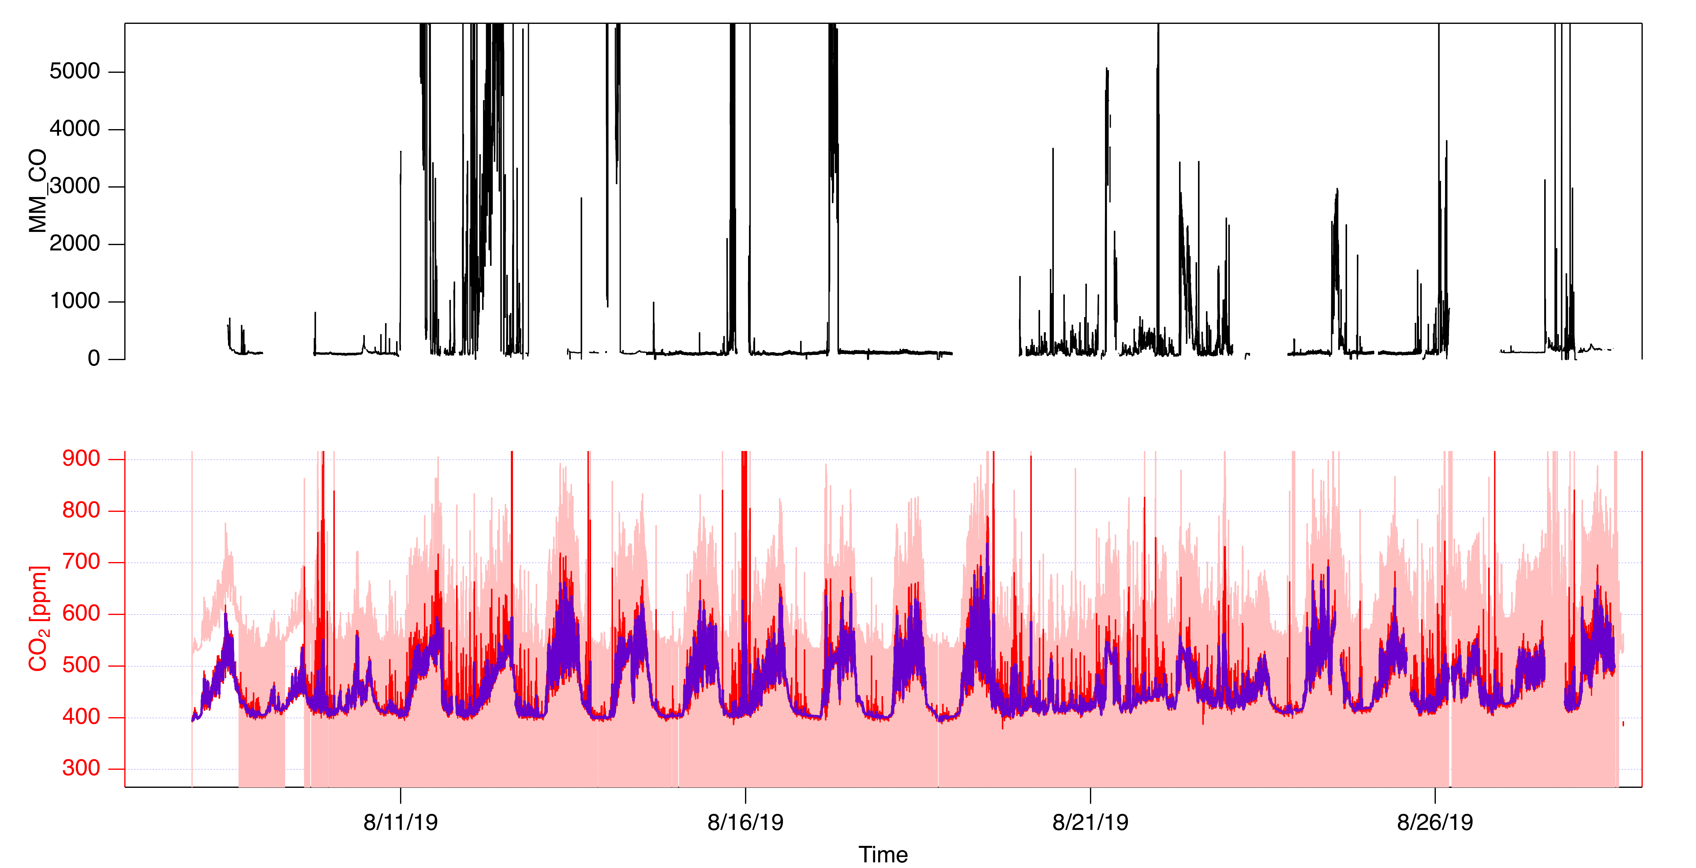

Collected on a Licor 6262 connected to the main gas-phase inlet. There was a major offset in raw concentrations (about 100 ppm) which was corrected by interpolating between zeroes.

An overblow calibration using the FIREX CO2 tank was performed on 8/28/2019. The calibration factor for this was 1.12 (i.e. the Licor was reading high). This calibration factor has been applied for the entire campaign.

There were two periods of very high concentrations that were set to NaN. It looked like there were plumes within these times, but there were abrupt step-like concentration changes that suggests a problem with the instrument.

The full analysis steps are reproduced below.

QAQCw_ResetListWaves("CO2");

QAQCw_zeroWaveReset(); QAQCw_zerofind("CO2",8,320, time2inlet=1)

QAQCw_NanThisClass("Blacklist;SelfSampling;Calibration")

QAQCw_NaNlargeDataGaps("CO2",5)

QAQCw_NaNmarquis(token="CO2",startTime=3648064560.6,stopTime=3648064738.3,minY=-121.617,maxY=1334.69) //08/07/2019 23:16:00, 08/07/2019 23:18:58

QAQCw_NaNmarquis(token="CO2",startTime=3649287604.8,stopTime=3649287632.4,minY=-8.75392,maxY=659.527) //08/22/2019 03:00:04, 08/22/2019 03:00:32

QAQCw_NaNmarquis(token="CO2",startTime=3648753025.2,stopTime=3648753052.3,minY=68.3023,maxY=614.046) //08/15/2019 22:30:25, 08/15/2019 22:30:52

QAQCw_NaNmarquis(token="CO2",startTime=3648216224.9,stopTime=3648216225.5,minY=-39.5254,maxY=262.807) //08/09/2019 17:23:44, 08/09/2019 17:23:45

QAQCw_NaNmarquis(token="CO2",startTime=3649795266.2,stopTime=3649795279.2,minY=-50.6085,maxY=236.173) //08/28/2019 00:01:06, 08/28/2019 00:01:19

QAQCw_NaNmarquis(token="CO2",startTime=3649846774.0,stopTime=3649857719.8,minY=-30.1074,maxY=3751.39) //08/28/2019 14:19:33, 08/28/2019 17:21:59

QAQCw_NaNmarquis(token="CO2",startTime=3648064716.2,stopTime=3648064979.4,minY=302.458,maxY= 564.12) //08/07/2019 23:18:36, 08/07/2019 23:22:59

//There are plumes here. very strange looking. QAQCw_NaNmarquis(token="CO2",startTime=3649443355.8,stopTime=3649445947.9,minY=-121.943,maxY=6086.64)

QAQCw_NaNmarquis(token="CO2",startTime=3649639194.5,stopTime=3649643157.9,minY=56.8945,maxY=5847.42) //08/26/2019 04:39:54, 08/26/2019 05:45:57

QAQCw_averageZeroHearts("CO2",useNanData=1)

QAQCw_zeroCorrection("CO2",4, maxDistBtwnHearts=1800)

QAQCw_NaNZeroes(1,1,tokens="CO2")

// CO2 calibration notes

// 0415 15:21 08/28/2019 firex co2

// There are actually 4 separate deliveries and the last one looks best.

// Overblow: 550.957

// Prev. Zero: 101.888

// 550.957-101.888 = 449.069

// Firex CO2 has 401 PPM +- 5%

// cal factor = 1.11987

root:a_CO2:co2_conc_NaNed /= 1.12

// Casting -- time to inlet is 0.

setdatafolder root:MMData;

Cast_AnyXYontoTimewave(MM_UTC, root:a_CO2:source_rtime, root:a_CO2:co2_conc_NaNed, "MM_CO2_ppm", "", time2inlet=str2num(GetElementStrFromToken("CO2", "TIME2INLET",era_datetime=text2datetime("8/21/2019 00:00")))

# O3

Ozone concentration in parts-per-billion (ppb), ambient humidity.

Tara Yacovitch, Aerodyne Research, Inc, tyacovitch@aerodyne.com

The 2B-Tech ozone monitor instrument measures O3 concentrations using direct absorption of a UV lamp output. The instrument reports the difference between a sample measurement and an O3-scrubbed measurement. More information about principle of operation is here: <https://twobtech.com/model-205-ozone-monitor.html>. In this configuration, the instrument is acquiring a data point every 2 seconds, which is then averaged to 1 minute in the MM_O3 data wave.

This instrument was mounted on the gas-phase line of the AML

### Data

|  |  |  |  |
| --- | --- | --- | --- |
| Name | Description | Units | 1 σ noise |
| MM_O3 | UV Ozone Sensor | ppb | 1.0 ppb |

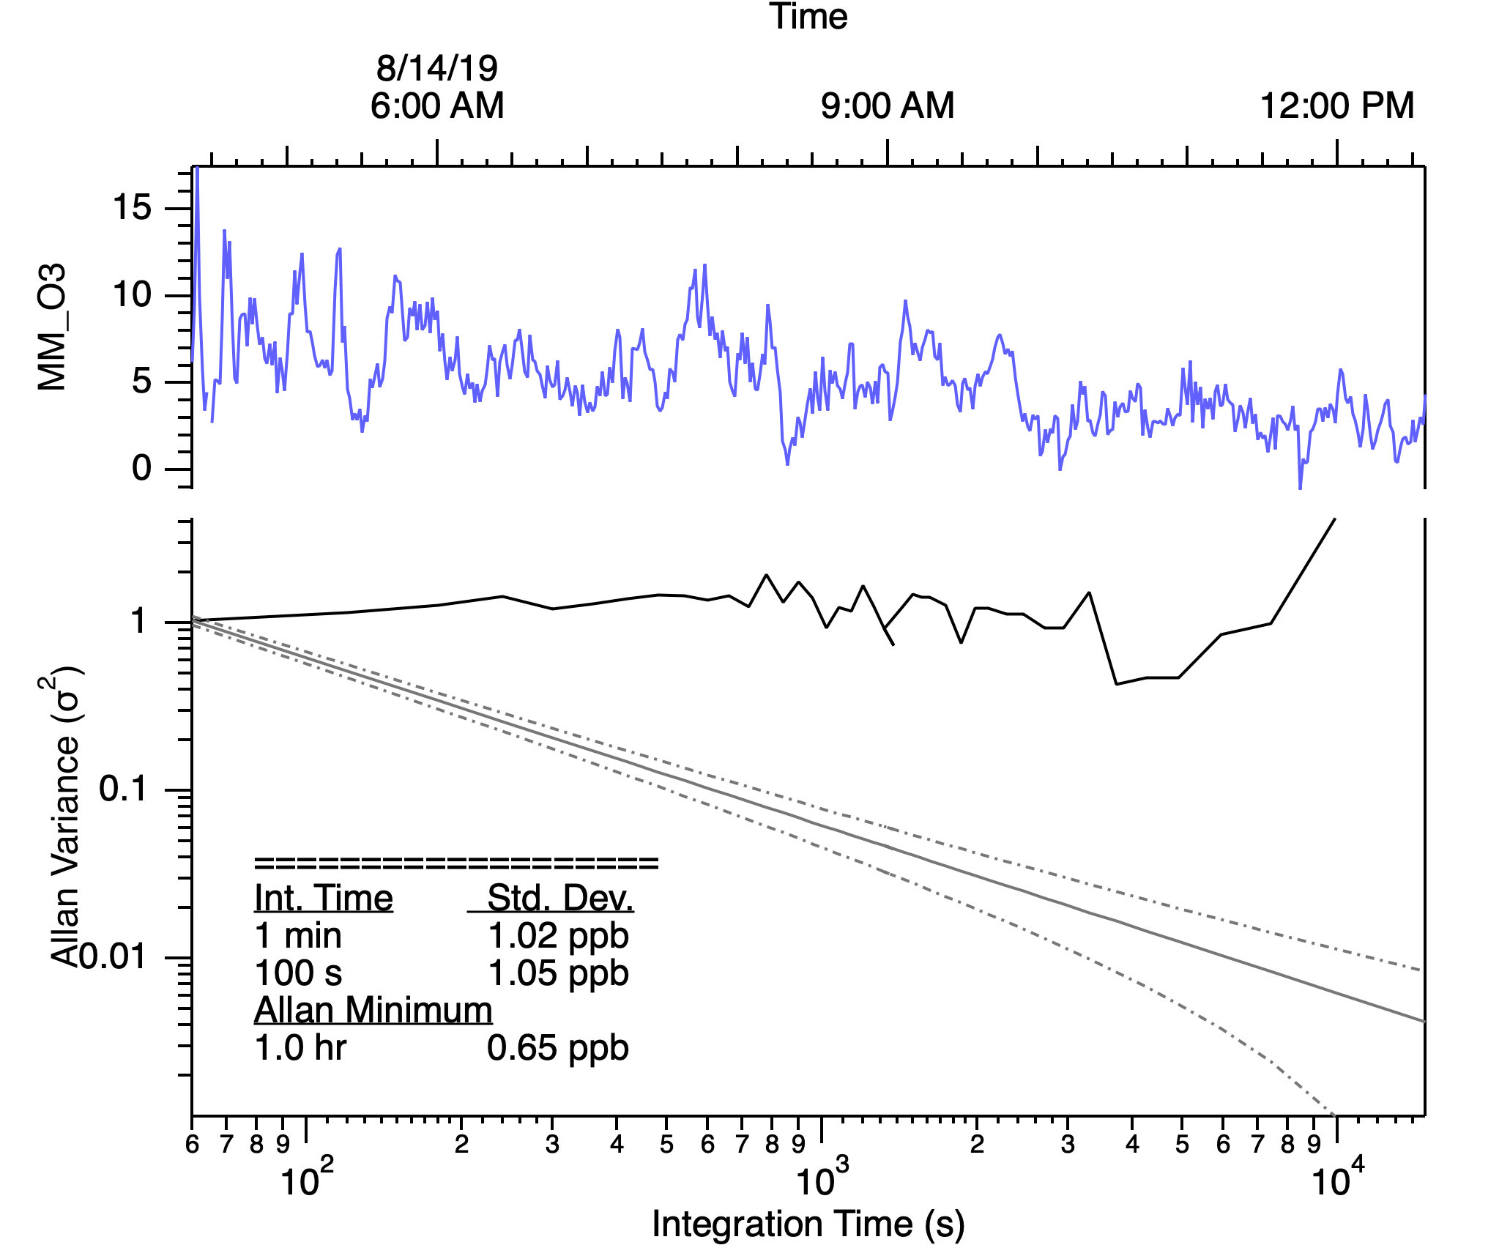

### Calibration, Zeroing, Corrections

The O3 measurement is uncalibrated. The zero level of the instrument was corrected by overblow the inlet with ultra-zero air every 15 minutes. The average zero offset is 0.56 ppb, and the distribution of these zeroes is shown in the histogram below. Zero offsets were corrected by linearly extrapolating between subsequent zeroes.

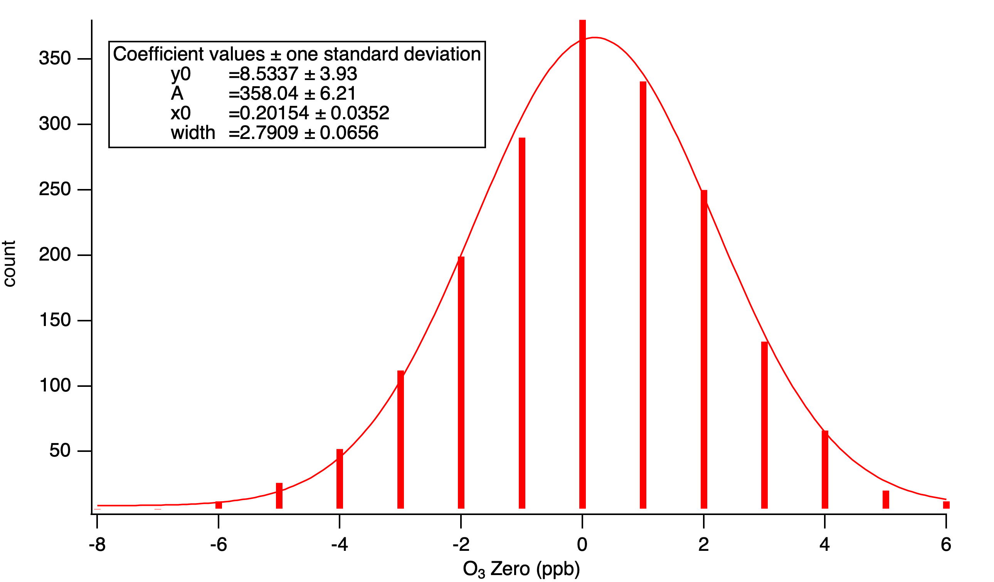

The data rate of this instrument is one datapoint every 2 seconds (0.5 Hz). The 2s noise is approximately 1.6 ppb, based on limited data when concentrations were somewhat stable, see figure below. This is fairly close to the 1-sigma variation in zeroes (1.16 ppb) that was calculated in the histogram above.

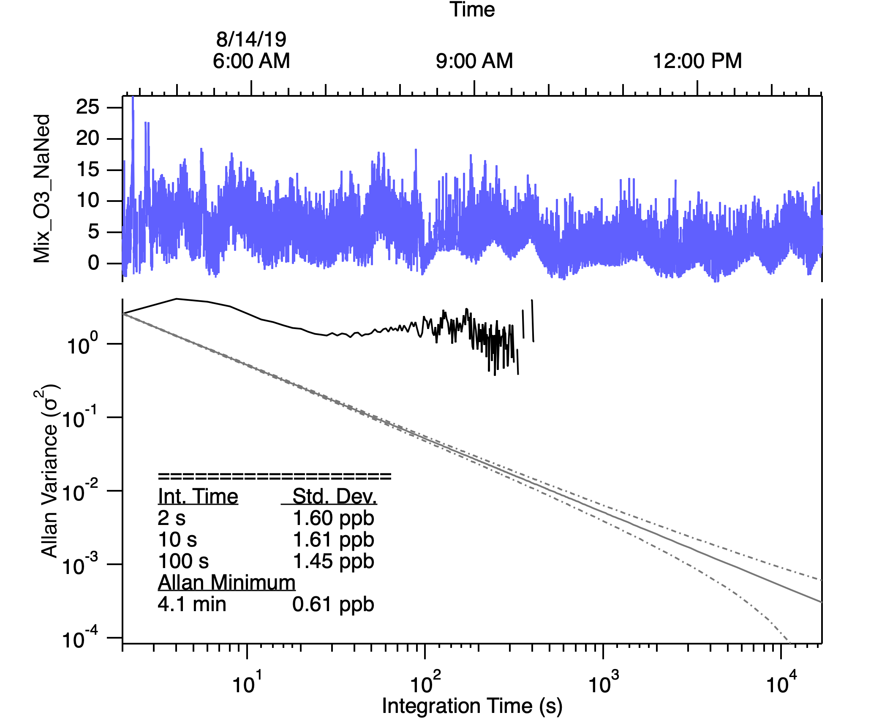

### Data issues

Known interferences to this UV absorption instrument include sulfur dioxide, aromatic hydrocarbons and others (Spicer et al., 2010).

There appears to be some periods in motion where the monitor reports rapid (single-point) negative excursions. These have been eliminated by using a threshold of less than half the average zero concentration.

The full analysis steps are reproduced below.

QAQCw_ResetListWaves("O3");QAQCw_NanThisClass("Blacklist;SelfSamp;Calibration")

QAQCw_NaNlargeDataGaps("O3",5)

QAQCw_zeroWaveReset(); QAQCw_zerofind("CO2",8,320, time2inlet=1)

QAQCw_NaNmarquis(token="O3",startTime=3648064588.3,stopTime=3648064728.4,minY=-51.6175,maxY=72.8409) //08/07/2019 23:16:28, 08/07/2019 23:18:48

QAQCw_averageZeroHearts("O3",useNanData=1)

QAQCw_zeroCorrection("O3",4, maxDistBtwnHearts=1800)

QAQCw_NaNZeroes(1,3,tokens="O3")

wavestats root:QAQC:zeroHearts_avg

QAQCw_clipIntensity("O3","O3",V_avg/2,1000,time2inletTF=0)

Setdatafolder root:QAQC;make/n=0/o hist_O3zero;Histogram/B={-8,1,15} zerohearts_avg, hist_O3zero

setdatafolder root:MMData;

Cast_AnyXYontoTimeWave(MM_UTC, root:a_O3:source_rtime, root:a_O3:Mix_O3_NaNed, "MM_O3", "", time2inlet=str2num(GetElementStrFromToken("O3", "TIME2INLET",era_datetime=text2datetime("8/21/2019 00:00"))))

SetScale/P x, MM_UTC[0], 60, "dat", MM_O3

setdatafolder root:SSData;

Cast_AnyXYontoTimeWave(SS_UTC, root:a_O3:source_rtime, root:a_O3:Mix_O3_NaNed, "SS_O3", "", time2inlet=str2num(GetElementStrFromToken("O3", "TIME2INLET",era_datetime=text2datetime("8/21/2019 00:00"))))

SetScale/P x, SS_UTC[0], 1, "dat", SS_O3

# PAMValve

A flag variable, set to 1 when AML instrumentation sampled from PAM inlet, and 0 when instrumentation sampled from regular ambient inlet.

# AML_at_AB

A flag variable indicating when the AML was stationed at the McCall Activity Barn Ground Site. It is 1 for activity barn data; 0 for data collected at other locations and while mobile.